**Data structures /10671210**

**Project 1** – Summer semester 2021/2022

**Objectives:**

* To demonstrate how to define classes and create objects.
* 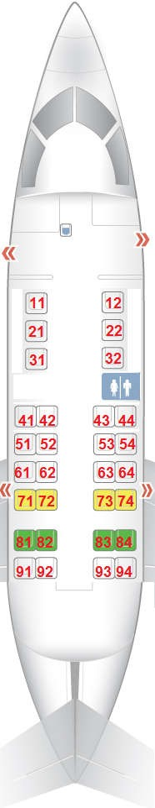To use multidimensional ragged arrays.
* To store and process objects in arrays.

**Task: Flight Reservation System**

In this phase, you need to consider a new small flight using the following seat layouts. Note that the first three rows have two seats only while the other rows have four seats.

* Create a **Seat** class that has:
  + Private **seat number**with getter and setter methods. o Private boolean **reserved** with getter and setter methods.
  + A constructor that takes seat number.
  + A **printInfo** method that prints out seat object information.
* Create a **Flight** class that has the following:
  + A private array of seats reflecting the new mentioned flight seat map.
  + A method **isValid** that takes a seat number and returns if the seat number is valid or not.

Then, write the main method that initializes the seats array and keeps displaying a menu containing the following options

* 1. **Reserve a newly empty seat.**
  2. **Delete a reserved seat.**
  3. **Delete all reserved seats.**
  4. **Print out flight seats map.**
  5. **Quit.**

The following is the details of each option:

1. **Reserve a new empty seat:** Implement this in a function as follow:
2. Ask the user to enter a valid seat number.
3. If the entered seat number is not valid, ask him to re-enter it again.
4. Else (if entered seat number is valid), check if the entered seat is not reserved (empty).
5. If not empty, display a message that the seat is not empty and ask him to reenter a new seat number.
6. Else (entered seat is empty), mark it as reserved.
7. **Delete a reserved seat:** Implement this in a function as follow:
8. Ask user to enter a valid seat number.
9. If the entered seat number is not valid, ask him to re-enter it again.
10. Else (if entered seat number is valid), check if the entered seat is reserved (not empty).
11. If empty, display a message that the seat is empty and ask him to re­enter a new seat number.
12. Else (entered seat is not empty), mark it as not reserved.
13. **Delete all reserved seats:**  Implement this in a function that marks all the seats as not reserved.
14. **Print out flight seats map**: Implement this in a function that returns the number of

reserved seats and print out the seat information as in the flight seats map + if the seat is

empty or reserved

1. **Quit:** this will exit the execution.

Good Luck!!!